Analysis of Crop production vs Food security in Africa

Introduction
Africa is rich in land, labour and natural resources for agriculture, yet food insecurity and hunger remain persistent challenges across the continent. Despite ongoing efforts to boost agricultural output, it remains unclear whether producing more food actually translates into better food security outcomes for the continent’s population. Which is why this critical question came to mind; DOES INCREASE IN AGRICULTURAL (CROP) PRODUCTION GUARANTEE IMPROVED FOOD SECURITY? This analysis examines crop production and undernourishment trends i.e. one of the food security indicators, from (2010–2024) across the African countries to assess this test.

This project was conducted as part of the requirement for completing the Data Analytics Program at WETIN DEY ACADEMY. Two datasets from FAOSTAT (Food and Agriculture Organisation Statistical Database) were used for this project and the analysis was carried out using Microsoft PowerBI.

Analysis Questions
- How has total crop production changed across Africa, 2010–2024?
- How has the prevalence of undernourishment changed across Africa over the same period?
- Do countries with the fastest-growing production also show the fastest-improving food security or not?
- Are there countries where crop production grew but undernourishment stayed flat or worsened? How many, and which ones?
- Are there countries where crop production fell but undernourishment (food security) still improved? What might explain this?
- Do the five African regions show different patterns between production and food security?
- Based on these questions and analysis, does the data agree to "increased crop production guarantees improved food security", fully, partially, or not at all?

Objectives
- To examine trends in crop production and food security (undernourishment) across Africa between 2010 and 2024
- To assess the relationship between production growth and undernourishment (food security indicator) at the country level
- To compare patterns between production growth and undernourishment (food security indicator) across Africa's five regions.
- To evaluate, based on the findings above, whether the data supports that increased crop production guarantees improved food security in Africa, and to determine whether this holds fully, partially, or not at all, concluding with actionable insights and recommendations.

Data Source and Description
The two datasets (Crop production and Food security data), were extracted from FAOSTAT (Food and Agriculture Organisation Statistical Database) on 11 August 2026, both datasets were last updated: 15/12/2025 and 21/07/2026. Here are the links and description of each dataset below.
https://www.fao.org/faostat/en/#data/FS
https://www.fao.org/faostat/en/#data/QCL

Crop production data - 12 columns, 15,715 rows | Food security data - 12 columns, 9,940 rows
Domain Code | Domain Code
Domain | Domain
Area Code (M49) | Area Code (M49)
Area | Area
Element Code | Element Code
Element | Element
Item Code (CPC) | Item Code (CPC)
Item | Item
Year Code | Year Code
Year | Year
Unit | Unit
Value | Value

Scope and Limitations
This analysis has some boundaries that are worth stating, in order for the findings to be understood in the right context:
- Six countries (Sudan, South Sudan, Burundi, Equatorial Guinea, Eritrea, and Lesotho) were excluded from all country level analysis due to incomplete data on either crop production or food security data, across the study period. All other findings are based on the 48 African countries with complete data.
- Prevalence of Undernourishment (PoU) is a supply-side indicator, estimated from national food balance sheets rather than direct surveys of individuals. Therefore, it can miss uneven food distribution within a country i.e. a nation could appear food-secure on paper while specific communities still go hungry.
- Crop production was analyzed in aggregate, rather than crop-by-crop, since the research question is on overall production volume relative to food security outcomes, not the performance of individual crops.
- Trade (imports/exports), conflict, food prices, population growth, and were not part of this dataset.

Data Cleaning and Transformation
Steps for crop production data are:
- The columns (domain code, year code) were removed because they were not needed i.e. no analytical value
- Duplicates were checked and none was found
- The missing values detected were approximately 0.7% of the dataset and it was handled appropriately
- Right data type was ensured across the columns.
- Texts were standardized in Item column, using the feature “replace value”.

Steps for food security data are:
- The columns (domain code, element code, element, item code and year code) were removed because they were not needed i.e. no analytical value
- Duplicates were checked and none was found
- The missing values detected were approximately 23.3% of the dataset and it was handled appropriately
- Right data type was ensured across the columns.
- Inconsistency was seen in Value column (< 2.5), the sign “<” was removed because it is FAO’s way of indicating a threshold below the required value.
- Texts were standardized, using the feature “replace value”, both Area and Area code column, were changed to Country and Country code respectively, for easy identification.
- It was a mixture of single and average year calculation, on the Year column, so the column was highlighted and the feature “split column” was used to separate into “start year” and “end year”, after which, a column, analysis year, was added.

After these steps, both datasets were activated by clicking “close and apply” and they were displayed on table view. A column “Dim_Region” containing country and region, was created, to serve as a means of connection between both datasets. The connection type was “many to one”, done in model view of powerBI. For this analysis, DAX measures and calculated columns were built and used where necessary.

Visualization
Below are the visuals that answered each analysis question, a dashboard overview with key analysis was also built, all done in powerBI.
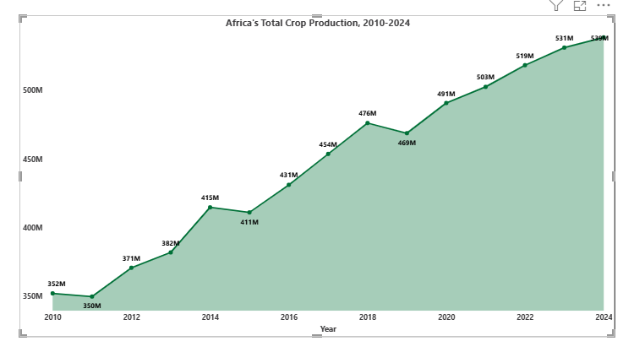
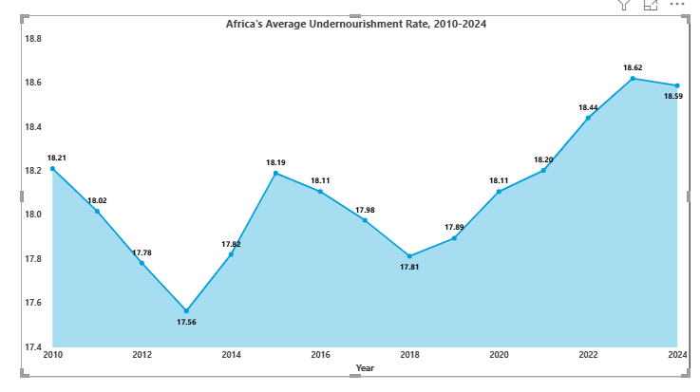

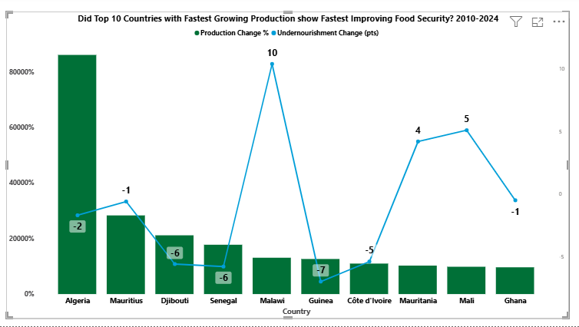

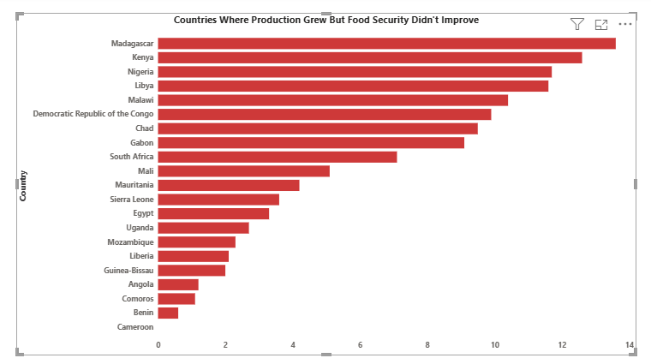

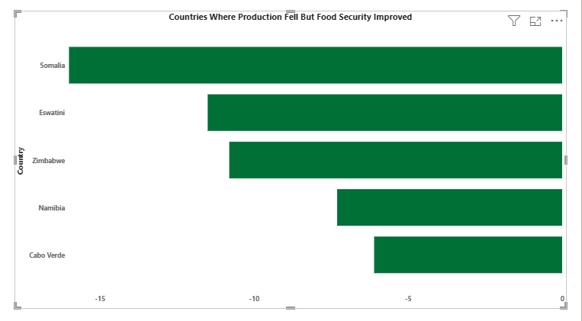

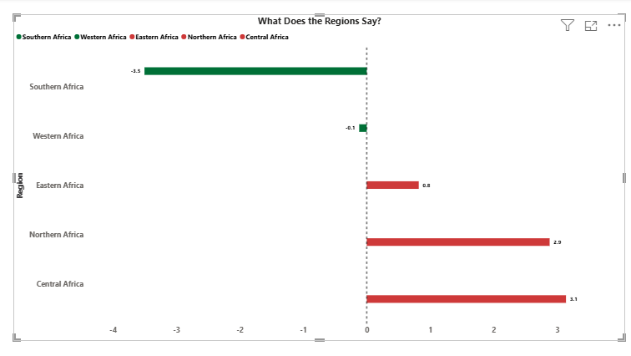

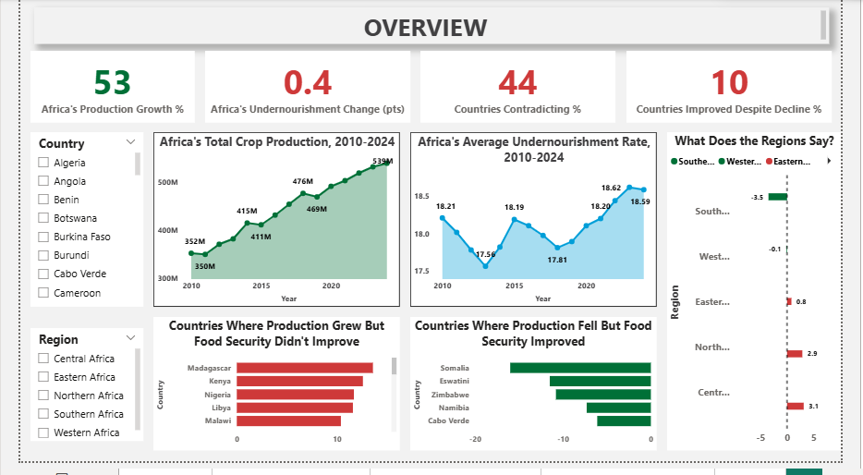

Insights
- Total crop production across Africa rose from approximately 352 million tonnes in 2010 to 539 million tonnes in 2024, a 53% increase over 15 years, with some year declines.

- Average undernourishment across Africa reduced from 18.21% in 2010 to 17.56% in 2013, then it reversed and went up to 18.59% by 2024.

- The comparison between every country's production growth against its food security change revealed no consistent relationship i.e. countries with the fastest production growth were not necessarily the countries with the fastest-improving food security.

- 21 out of 48 countries with complete data (44%) had increased crop production between 2010 and 2024 while undernourishment stayed flat or worsened i.e. food security did not improve.

- Somalia, Eswatini, Zimbabwe, Namibia, and Cabo Verde had improved food security despite falling crop production. Somalia is the most striking case: a 45% decline in production alongside a -16 pts (pts - percentage points) improvement in undernourishment.

- Central Africa recorded the weakest improvement, with an average undernourishment change of + 3.1 while Southern Africa showed the strongest improvement, at -3.5.

Recommendation
- Let’s look beyond the harvest to get food to people: 21 countries grew more food, yet food insecurity stayed the same or even got worse. Therefore, the whole journey of food distribution from the farm to a family's plate should be properly examined by ensuring good roads for transportation of food crops, good storage and preservation practices, fair market prices for affordability.

- Countries like Somalia and the remaining four, experienced improved food security despite low production. Therefore, other countries can as well learn from what worked for them and see if it can be replicated and implemented.

- The focus should not only be by, how much food is grown, but also, how much food is secured. Therefore, governments should keep track of food security trends.

Conclusion
Across Africa, crop production rose by 53% between 2010 and 2024, yet average undernourishment did not reduce, with it, 2024 ended slightly higher than where it started. At the country level, in 21 out of 48 countries, crop production grew but food security did not improve while in 5 countries, crop production fell but food security did improve. The pattern was also visible in region, with Central Africa having the highest average undernourishment change and Southern Africa having the lowest. In conclusion, this analysis shows that, increase in crop production does not necessarily guarantee improved food security in Africa.

